Model Aeronautics
Association of Canada
Unit 9, 5100 South Service Road
Burlington, ON L7L 5H4
Attn: Linda Patrick cc Chris Brownhill - FAI Committee Chairman
cc Frank Klenk - Chair of Chairs
Hi Linda,
The F2B Team Trials were conducted on Sunday September 20th at Crowland Park in Niagara Falls Ontario. Crowland Park features an extremely nice paved control line circle located in an area free of trees and buildings that can cause turbulence.
The Team Trials were conducted using the current FAI rules by CD John McFayden 14681L and judging was handled by three experienced F2B competitors namely Dave Kelly 3070, Geoff Higgs 5521 and Chris Brownhill 3797L. Tabulator was Naomi Macklem 82384.
There were 5 entrants in the Team Trials, Konstantin Bajaikine 61045, Peter Hanson 65002, Len Bourel 14801, Pat Mackenzie 8177L and John McFayden 14681L.
The results were as follows:
Pilot | Score
Peter Hanson | 2322.03 | 1 st
Konstantin Bajaikine | 2302.56 | 2 nd
Len Bourel | 2251.33 | 3 rd
Pat Mackenzie | 2235.34 | Alternate
John McFayden | 2128.76

Enclosed is a cheque for $125 for the FAI Travel Fund collected at this event.
Respectfully submitted,

John McFayden 14681L
Committee Chair, Control Line Precision Aerobatics
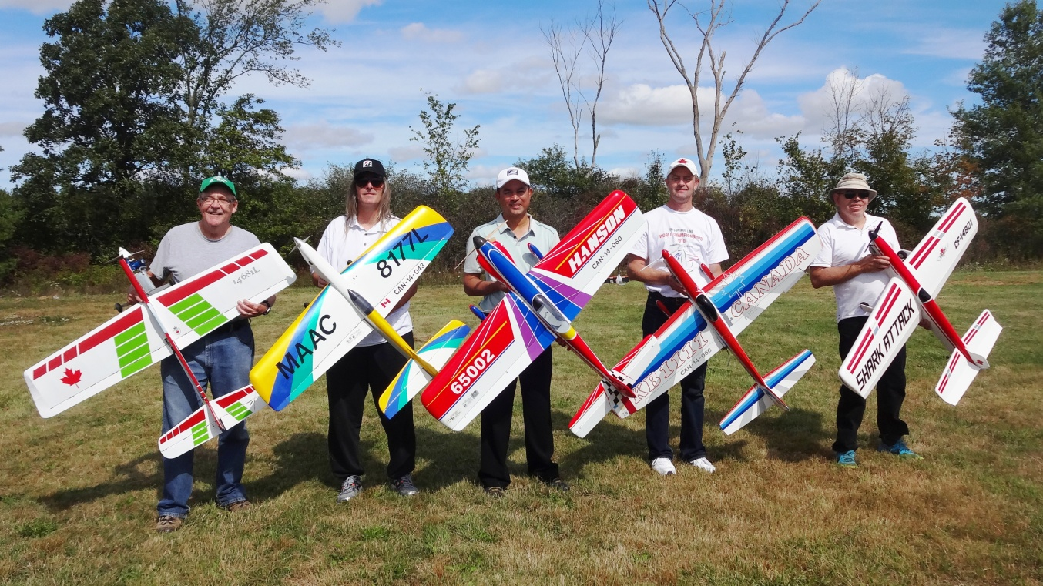
Left to Right : John McFayden, Pat MacKenzie, Peter Hanson, Konstantin Bajaikine, Len Bourel
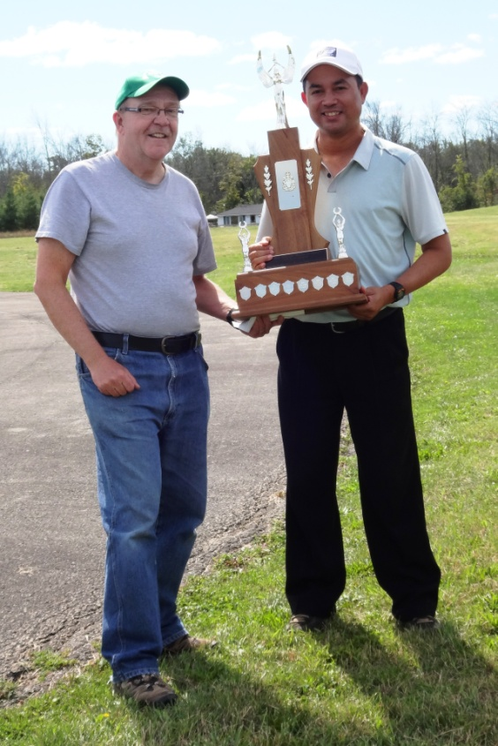

John McFayden presenting Peter Hanson the Rob Kolarik Trophy as the F2B Team Trials Champion.

